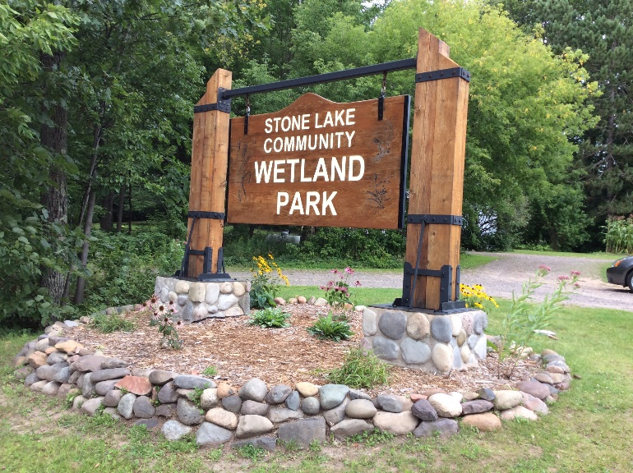

THE STONE LAKE COMMUNITY WETLAND PARK IS LOCATED ON STATE HIGHWAY 70 IN THE VILLAGE OF STONE LAKE, WISCONSIN

FOLIAR SPRAYING OF BUCKTHORN

This important job began the week of September 12, 2021, and continued well into October. Craig Baldridge, David Turnham, and Don Bushek worked in several areas of the Wetland Park according to where the need was the greatest; and made great headway on spraying as much buckthorn as possible in those areas. Buckthorn is easily identified in the fall; as it is the only bright green plant remaining. A sincere thank you to those three men for their very important work toward totally eradicating buckthorn in the Wetland Park.

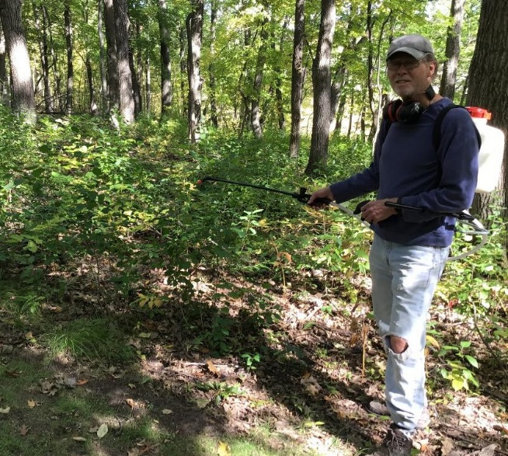

Craig Baldridge spraying the buckthorn

NEWSLETTER
VOLUME 5, ISSUE 1
NOVEMBER, 2021

WETLAND PARK COMMITTEE

Cathie Erickson Betty Hanson
Tom McDonnell Carol McDonnell
Bruce Gillette Marlo Schield

MAILING ADDRESS: N5779 Division Avenue
Stone Lake, WI 54876

EMAIL ADDRESS: tncmcd@aol.com
WEBSITE: www.stonelakecommunitywetlandpark.com

NEW CLOVER PATH IS POPULAR

The newest path, called the Clover Path, is a shortcut from the picnic area at the end of the boardwalk. It offers a totally new view of the Wetland Park, the town of Stone Lake, and the six-acre wetland.

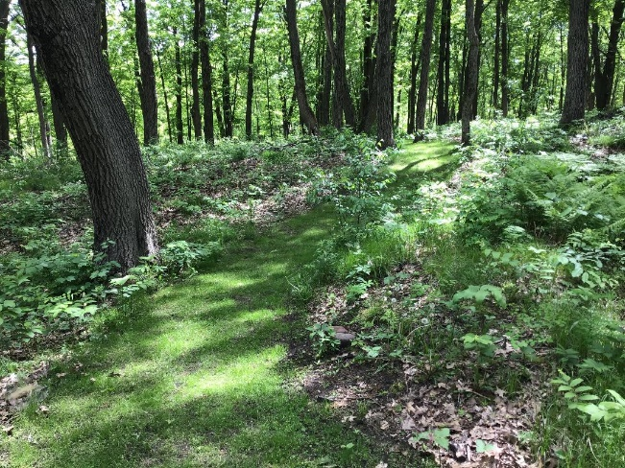

The new “Clover Path”

THANK YOU TO OUR VOLUNTEERS AND DONORS

In our newsletters, you will see the many ways our volunteers work in our Wetland Park to keep it safe and beautiful. Also, many costs are associated with maintaining the Park, and we thank our donors for their generous cash donations.

CLEARING DEBRIS FROM THE CREEK

One of the most difficult jobs that must take place each spring is clearing out the sand and debris that blocks the flow of water through the culvert under highway 70 into the wetland. At the same time, the rocks on both sides of the waterway leading into the Wetland Park must be rearranged after being dislodged by the winter snow plowing.

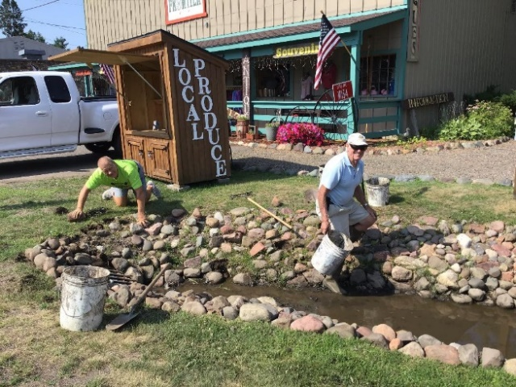

Woody Glass and Tom McDonnell working on the creek Rip-Rap

ANNUAL BOARDWALK REPAIR

Norbert and Darlene Gundry have once again replaced several boards in the boardwalk; and we thank them for recognizing the need for repairs or replacement. Using good judgment, they replace damaged boards whenever they see them. Replacing boards is a difficult job, and we are very grateful for the Gundry’s dedication to keeping the boardwalk in good repair.

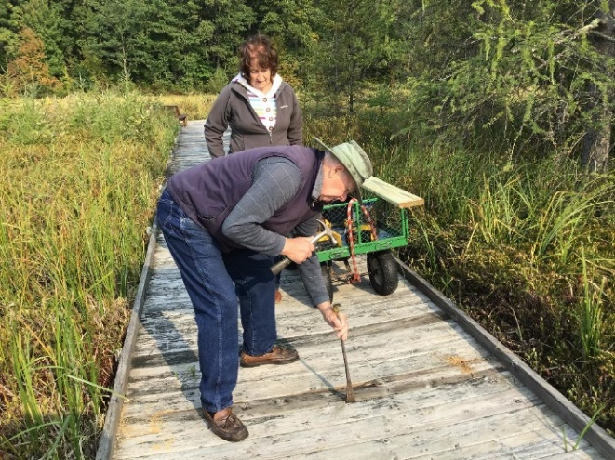

Norbert and Darlene Gundry working on repair of the Wetland Park Boardwalk

PAGE 2

PUBLIC RESTROOMS GET A FACE LIFT

Our beautiful public restroom building was given a face lift this summer; with a new coat of stain in a color called “Foothills”. The building looks brand new; when in reality it is 13 years old. Many of you may not know that the Wetland Park was awarded a $65,000 grant from Louisiana Pacific in 2008 to be used to build these restrooms for the park. They have turned out to be a very welcomed addition to our community.

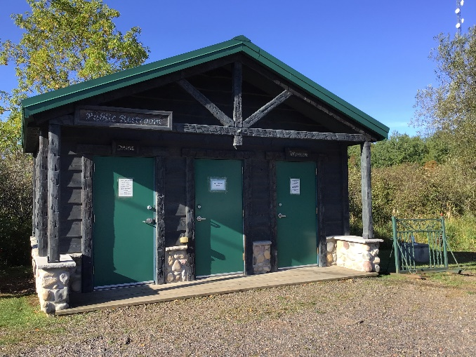

The Public Restroom Building after the “Face Lift”

CAN YOU SEE THE HIDDEN BABY DEER?

Craig Baldridge came across a tiny deer hidden in the Wetland Park by its mother. The baby stayed motionless for several hours until its mother returned.

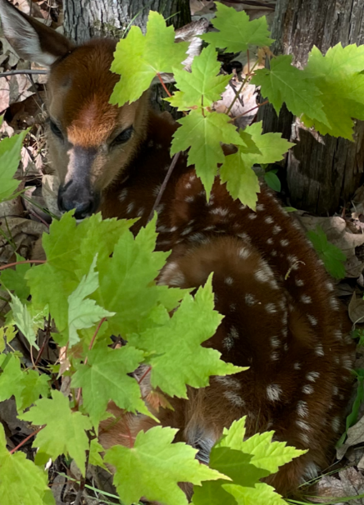

Can you see the baby deer?

ASPIRING EAGLE SCOUT SELECTS STONE LAKE COMMUNITY WETLAND PARK

The Wetland Park received a wonderful surprise recently. It has been named the beneficiary of an aspiring Eagle Scout’s efforts. Colin Byrkit, grandson of Bill and Mary Byrkit is working toward his Eagle Scout and has developed a plan on how he can direct his efforts to the Wetland Park.

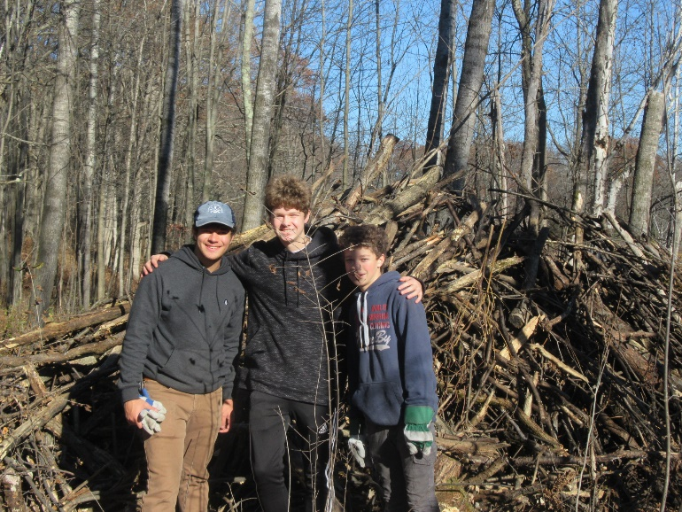

Three of the scouts working on Colin Byrkit’s Eagle Scout project

Here is an excerpt from Colin Byrkit’s application to the Scouting program: My name is Colin Byrkit. I am currently a Life Scout (Boy Scouts of America). I live in Woodbury, Minnesota. My connection to Stone Lake, Wisconsin, is that our family has been on this lake since the early 1950s. More recently, my grandparents (Bill and Mary Byrkit) built their year-round home in 2004. Stone Lake has always been a second home for me and like my parents, I am making my own memories. Typically, scouts in my troop do local Eagle Scout projects; however, I wanted my project to be in the community that meant something personally to me and my family: Stone Lake and, specifically, the Wetland Park. My major reasons for selecting the Wetland Park are both civic and personal: the community that supports the park are neighbors, friends, and family. And, I have walked the park countless times, and every time it reminds me of walking in the woods with my family.

The project consists of two parts: fall, 2021, restoration and conservation focusing on the

PAGE 3

buckthorn areas near the wetlands; and secondly, the activities in spring, 2022, to be directed toward reopening activities. We will be leaving existing deadfalls to decompose and provide natural fertilizer to the natural habitat. By cleaning up the brush and buckthorn located throughout the park; we will be promoting healthier growth by allowing for better airflow and sunlight; and it will be more appealing to visitors of the park. Upon completion of this project; it will mitigate the risk of wildfires due to “fuels” (downfalls and buckthorn) that could start the fire or cause the fire to grow. Additionally, this project will improve the accessibility and appearance of the park. I plan to build large brush piles in the parking lot and designated areas; that will be burnt during the winter.

Buckthorn is an invasive species to the Northwoods of Wisconsin. Buckthorn disrupts the balance of our natural woods by pushing out the desirable native understory plants and creating a dark, dense thicket that restricts those native plants from getting the nutrients it needs.

Finally, there will be a spring clean-up project that will also include projects such as: a ramp at the shelter, culvert clean-up, and tree planting. The ramp will be placed at the gazebo since there is a step difference providing for better accessibility and greater safety. In working with the beneficiary, we are targeting to plant a few trees throughout the park in designated areas. The goal of the trees is to suspend erosion, promote more natural wildlife, and scenery in those areas.

The park presently has a book box with conservation-friendly books. I plan to conduct a Book drive within my troop to support their local free library box.

STONE LAKE COMMUNITY WETLAND PARK MEMBERSHIP

We are happy to report that we now have 210 members: 131 of them lifetime members and 79 who renew yearly. We have included a Membership Coupon so we can save the cost of a special yearly renewal mailing. Members who wish to renew their memberships or make a special donation to the Wetland Park, please mail the completed coupon to the address shown on the coupon. WE THANK ALL OF YOU FOR YOUR CONTINUED SUPPORT!

Stone Lake Community Wetland Park
N5779 Division Avenue
Stone Lake, WI 54876

MEMBERSHIP APPLICATION

I would like to become a member of the Stone Lake Community Wetland Park membership organization.

NAME: ___________________________________

ADDRESS: _________________________________

__________________________________________________________________

PHONE: __________________________________

[ ] LIFETIME $ 100.00
[ ] FAMILY $ 20.00/year
[ ] INDIVIDUAL $ 5.00/year

[ ] PIease accept my donation to help with Park
maintence and I understand that my gift will
be acknowledged upon receipt.

Mail to: Stone Lake Community Wetland Park
N5779 Division Avenue
Stone Lake, WI 54876.

Donations to the Stone Lake Community Wetland Park may be tax deductible

BRICK PURCHASE APPLICATION

We wish to purchase a brick to be placed in the Memory Walk at the Stone Lake Community Wetland Park. Wording on the brick should be as follows (up to three lines, 14 characters per line maximum):

__________________________________________

____________________________________________________________________________________

____________________________________________________________________________________

MY NAME: ________________________________

ADDRESS: _________________________________

CITY, STATE, & ZIP: __________________________

__________________________________________

PHONE (in case of questions): _________________

__________________________________________

My check for $55 per brick is included, made out to Stone Lake Community Wetland Park. Send to: N5779 Division Avenue, Stone Lake, WI 54876

